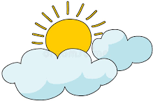
Clouds & Flights
Activity 1: The Cloud Whisperer
Sketch and Label: Identify which cloud in the atmosphere.
(High, Icy)
2. (Mid/Low, Fluffy)
3. (Vertical, Thunderstorm)
The Formula for a Cloud: What three essential ingredients are needed for a cloud to form?
1. 2. 3.
Challenge Question: A pilot needs to fly through a layer of Stratus clouds. What is the biggest challenge these clouds present (Visibility/Turbulence/Ice)? Explain why.
Challenge: Explanation:

Cloud Type | Typical Altitude Zone | Primary Impact on Aircraft  (Visibility/Turbulence/Icing) | Pilot Action Needed
Cumulus | Low to Mid-Level
Cumulonimbus | Vertical (Thunderstorm) |  | MUST fly around it.
Cirrus | High-Level
Fog (Stratus on the ground) | Ground Level | Poor Visibility | Use Instruments for takeoff/landing.

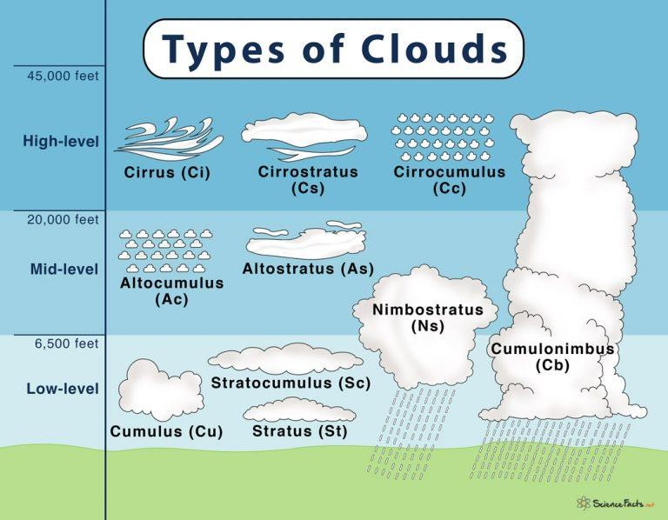
The Problem: Icing is a major danger when flying through clouds that have specific temperature and moisture levels. Ice adds weight, changes the wing shape, and reduces lift.
Your Task: Design a simple modification or system for an aircraft to counter icing.
System Name:
Science Concept Used (S): (e.g., Heat transfer, Chemical reaction)
Technology/Engineering (T/E): (How does it work/What is it made of?)
Team Wrap-Up & Reflection
The most surprising thing you learned about clouds and flight was:

